Event Name : Photowalk
Date : August 23, 2014
Location : National park, Guindy

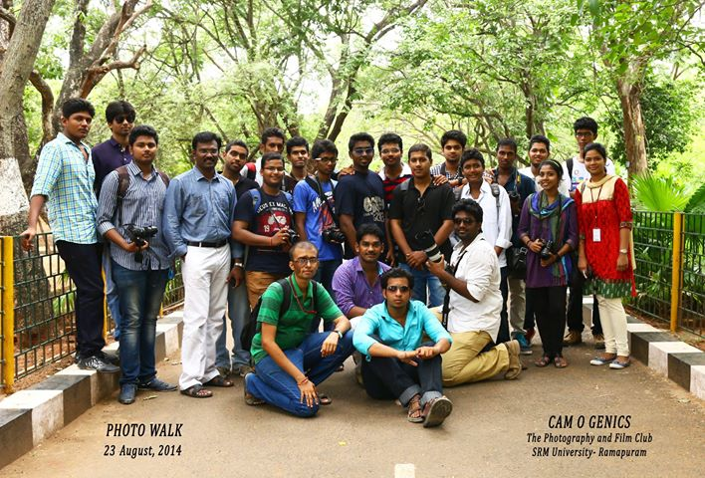

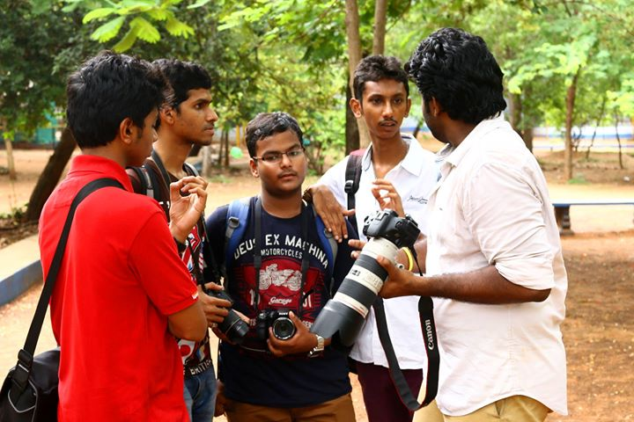
Trained photographer (Mahesh Krishnan - Vice president) were engaged to teach the newcomers.
