Event Name : Smile contest
Date : Septmeber 21, 2015

Event Name : Theme based event – Splash
Date : 15 Sept, 2019

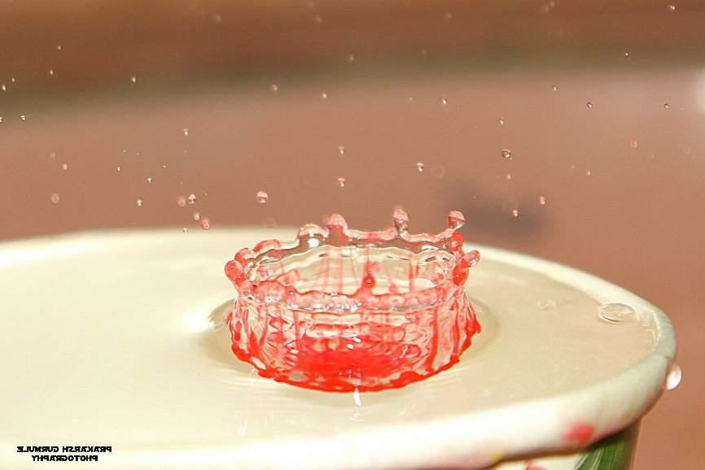

Event Name : Theme based event – Black color
Date : 15 July, 2018

