Photo Gallery
Event Name : Monocle’16
Date : April 2, 2016
Chief guest’s : Famous actor and comedian, Power star (Dr. Srinivasan), Mr. G P Krishna, Cinematographer Mr. C J Raj Kumar, Author and Cinematographer

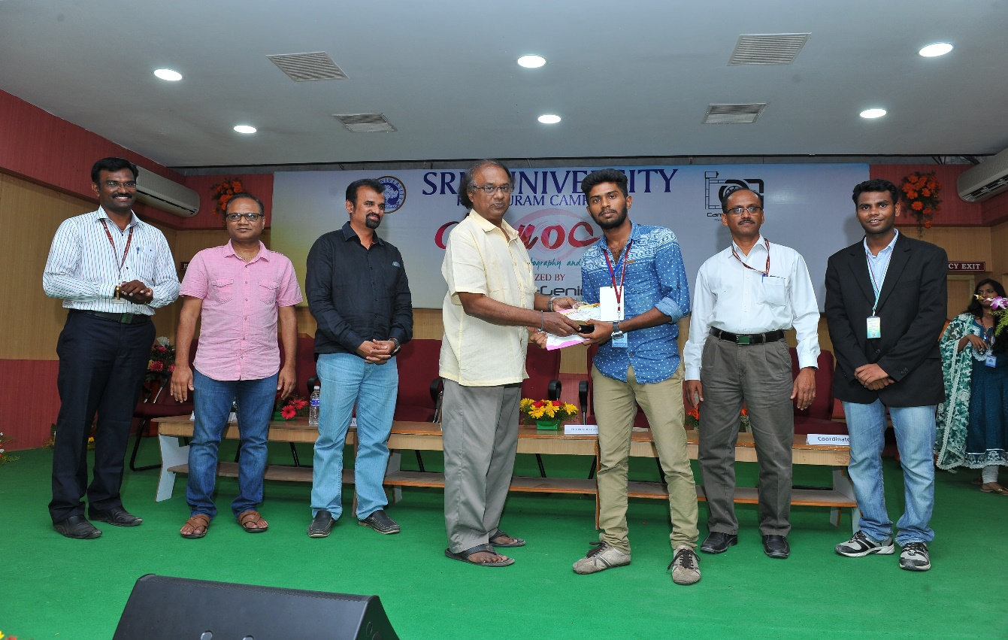
From left C.Aravindan Convener, CJ Raj kumar Author & Cinematographer, R D Balaji HOD/SRM Sivaji film Institute, GP Krishna-Chief Guest, Dr.L.AntonyMicheal Raj - Vice Principal (Academic), Sanath-Student Coordinator.
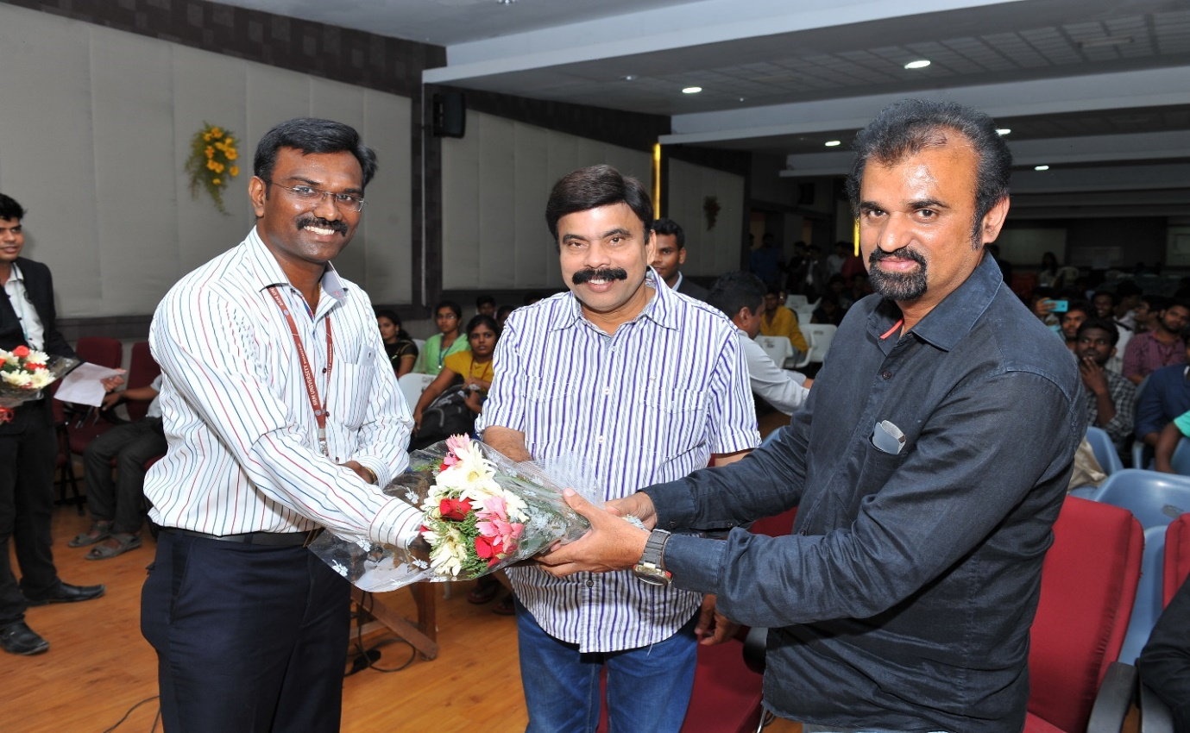
The famous actor and comedian, Power star- Dr. Srinivasan
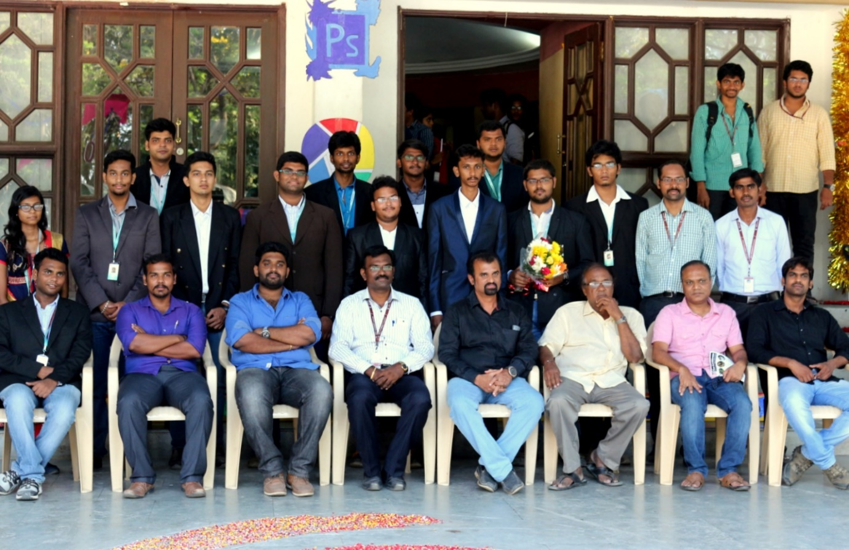
Team members of Monocle’16

Event Name : Monocle’17
Date : March 18, 2017
Chief guest’s : Pradeep Kalipurayath-Indian advertising director,
Cinematographer, Filmmaker
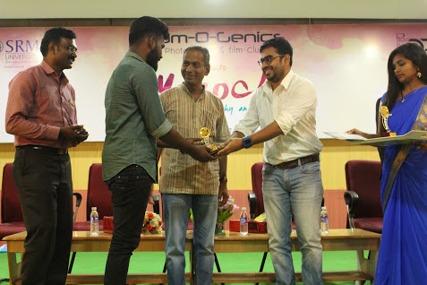
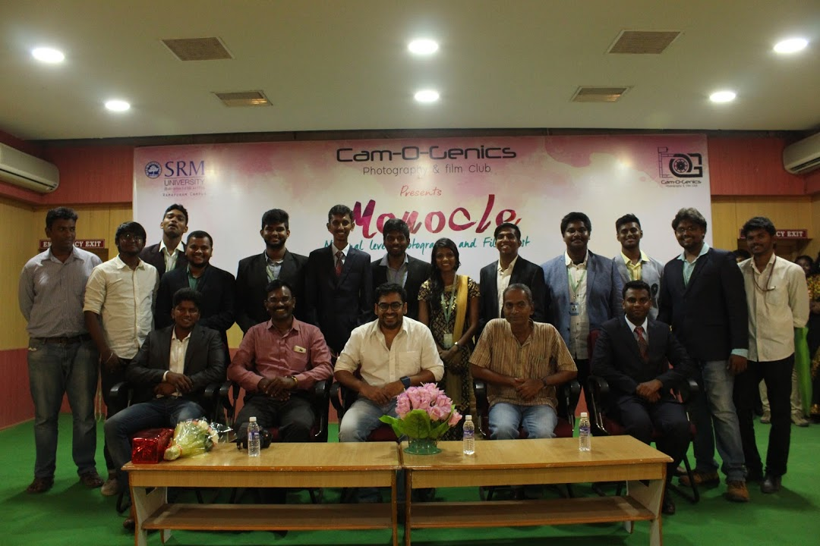
Team members of Monocle,17

Event Name : Monocle’19
Date : March 5 & 6, 2019
Chief guest’s : Mr. Rajesh M. Selva, Director of Thoongavanam and KadaramKondan, Mr. San Lokesh, editor of Ratsasan and Mr. Aravinnd Singh, Cinematographer at Demonte Colony
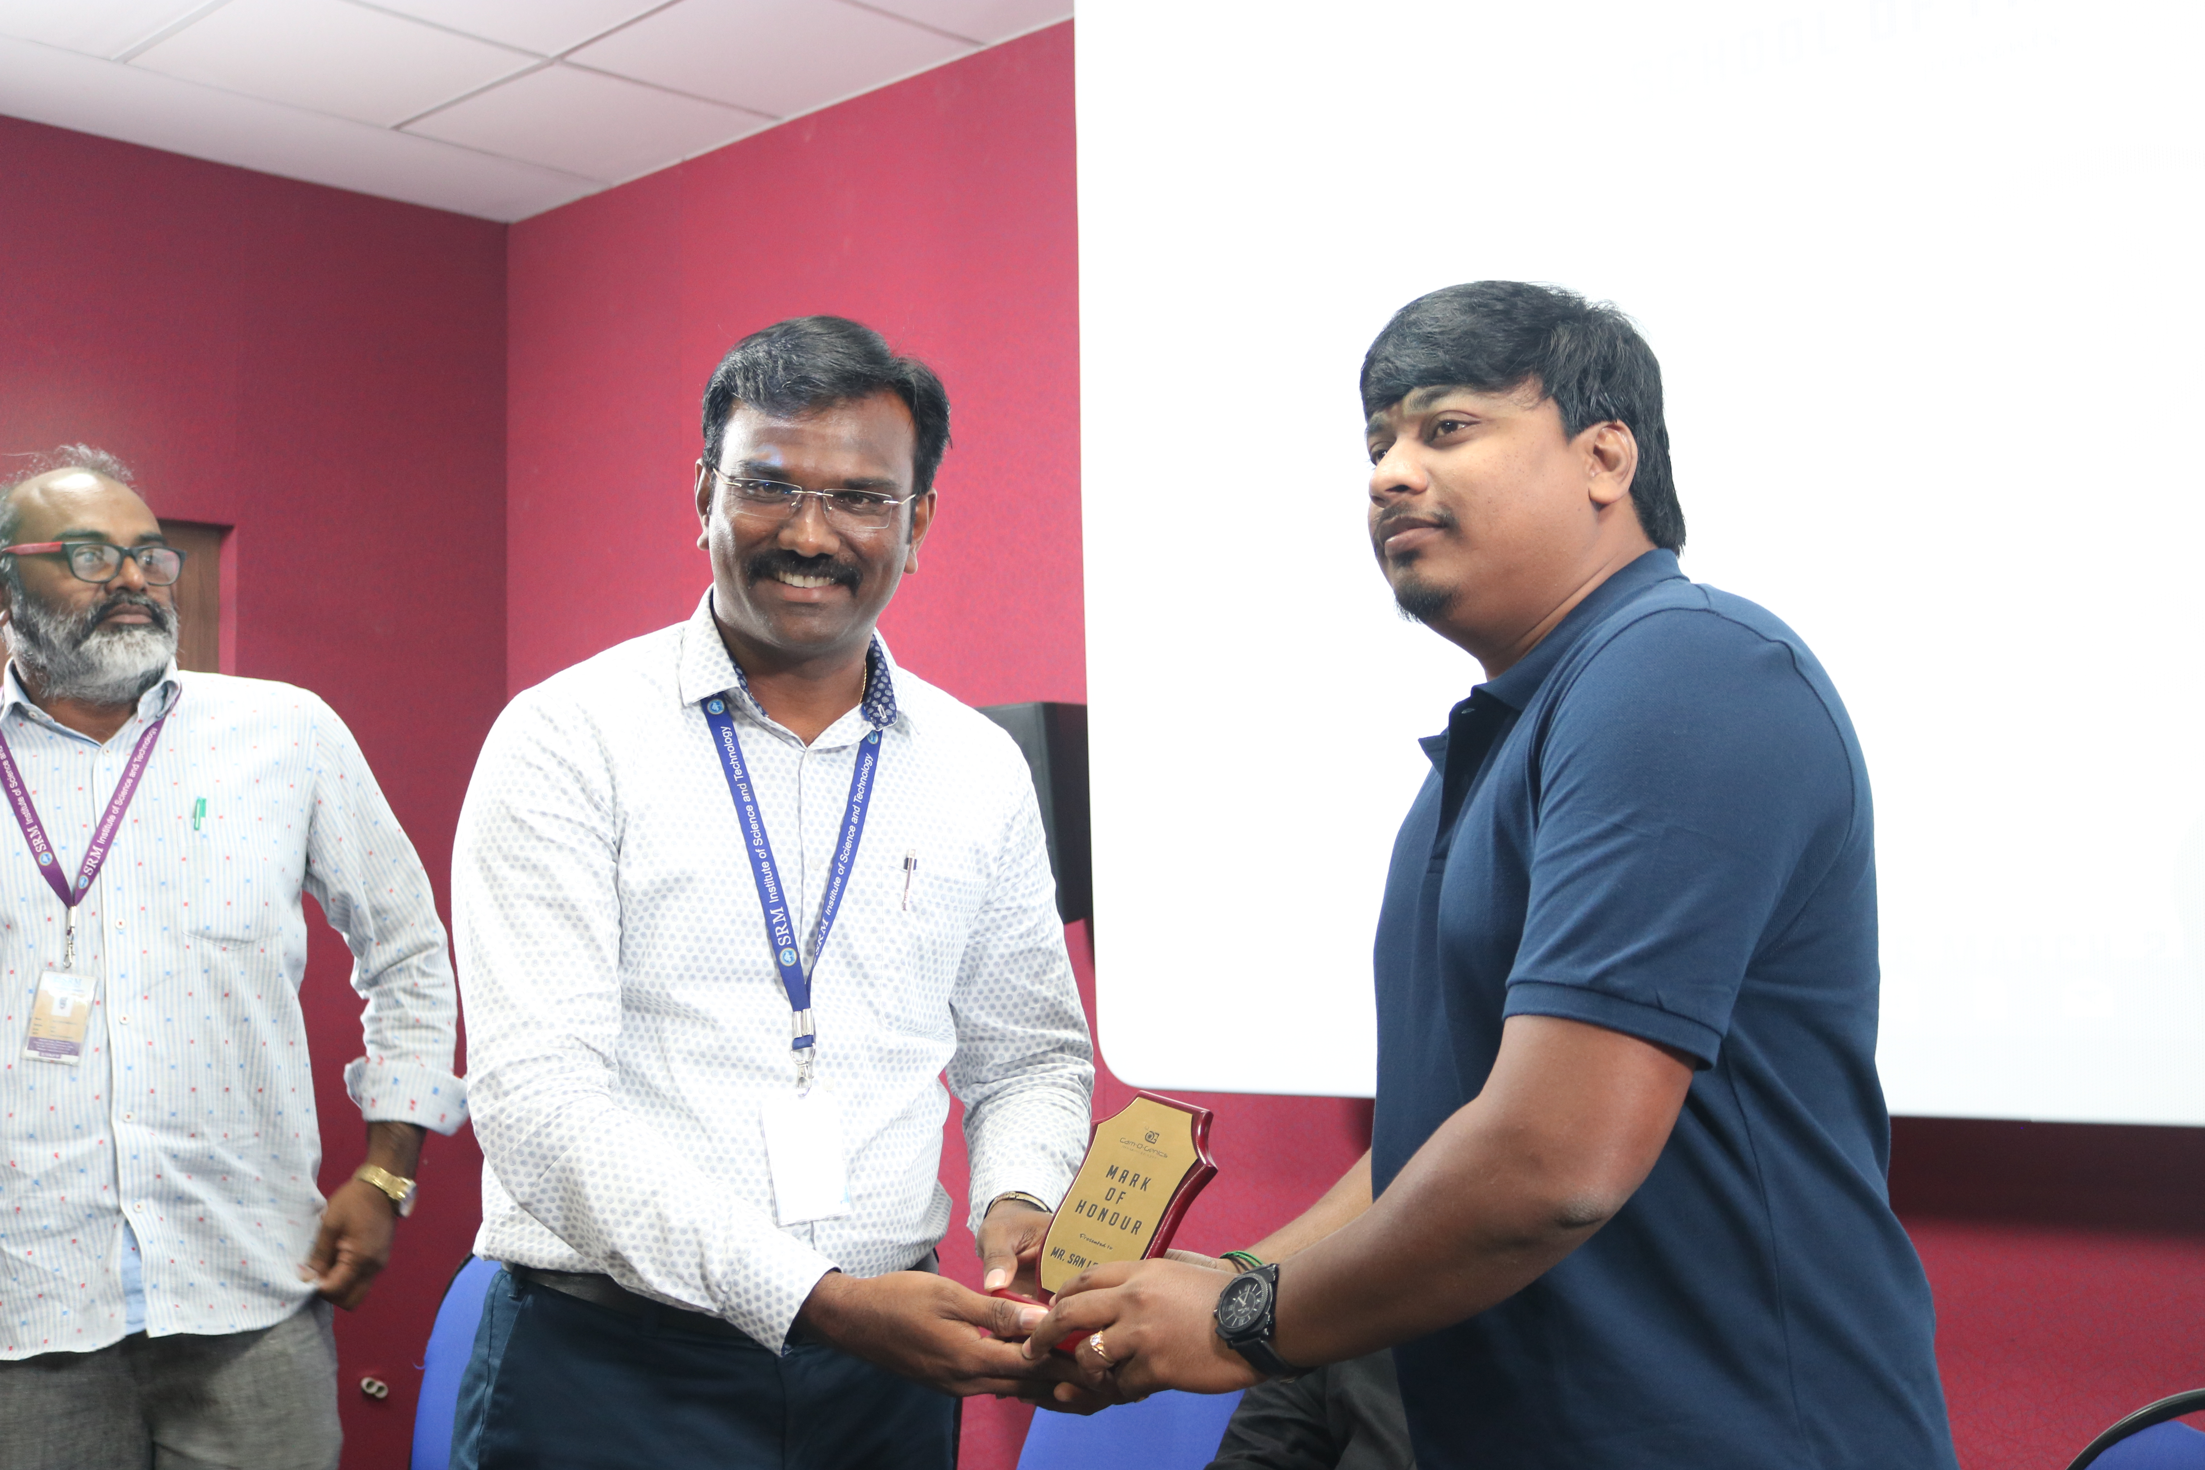

Mr. San Lokesh, Editor
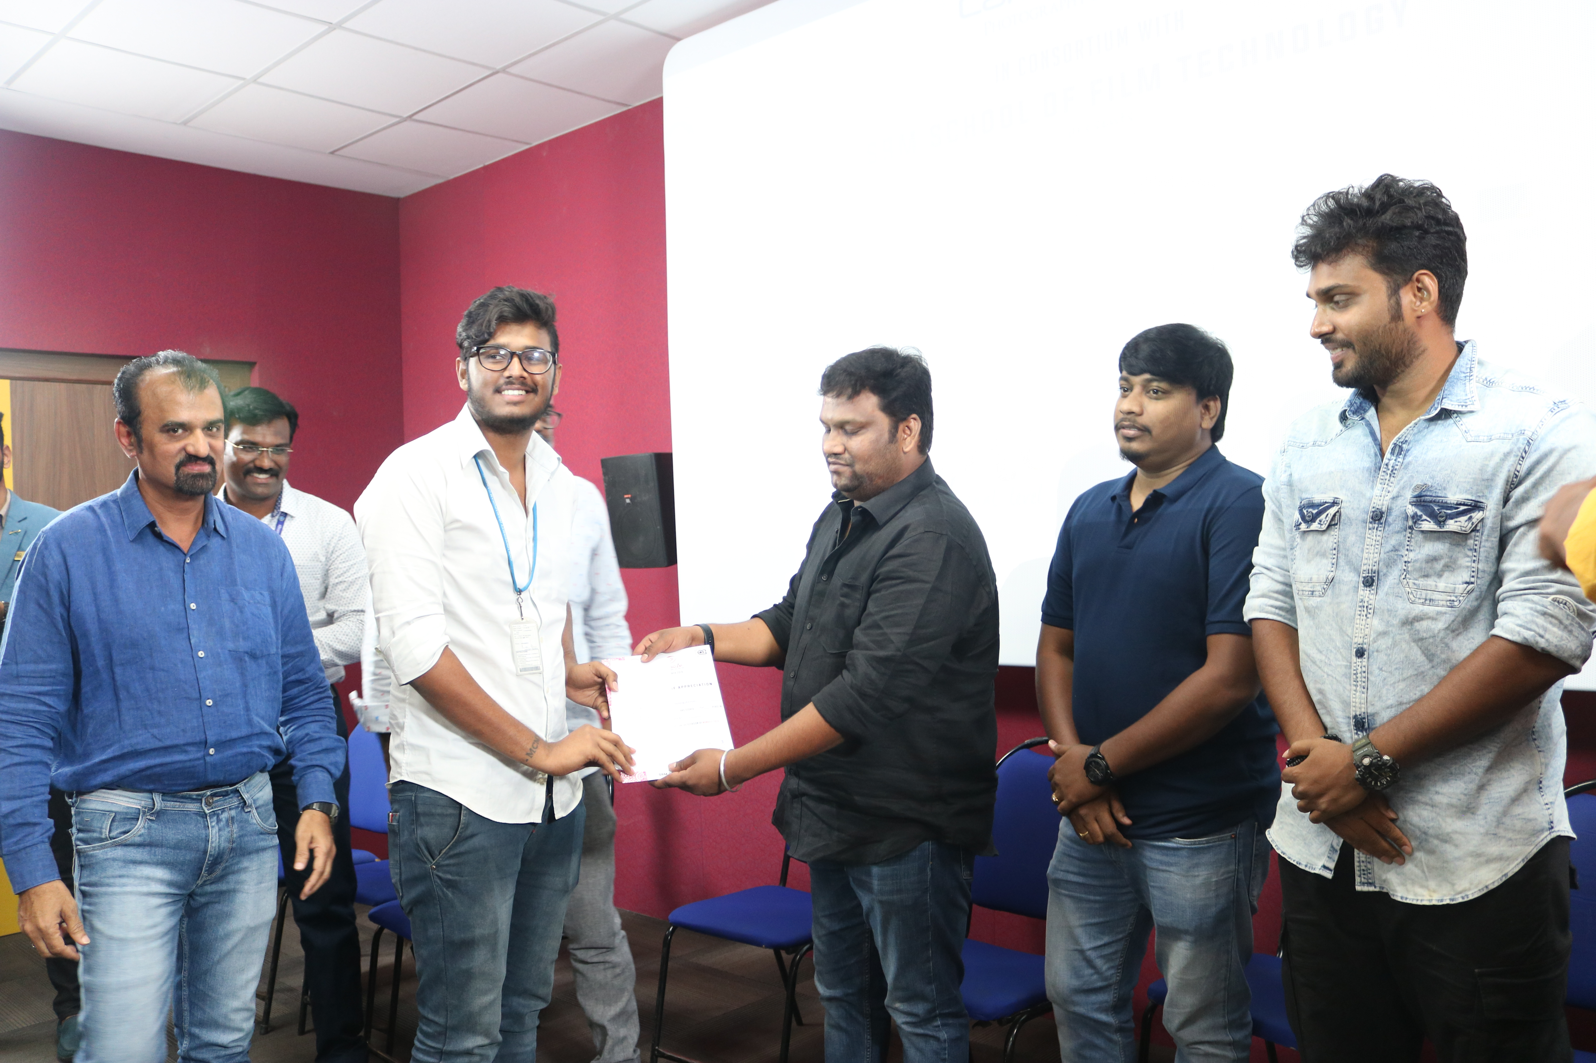
From the Left: R.D.Balaji HoD/Film Tech, Student Winner, Mr. Rajesh M.Selva, Director, Mr. San Lokesh, Editor and Mr. Aravinnd Singh, Cinematographer.
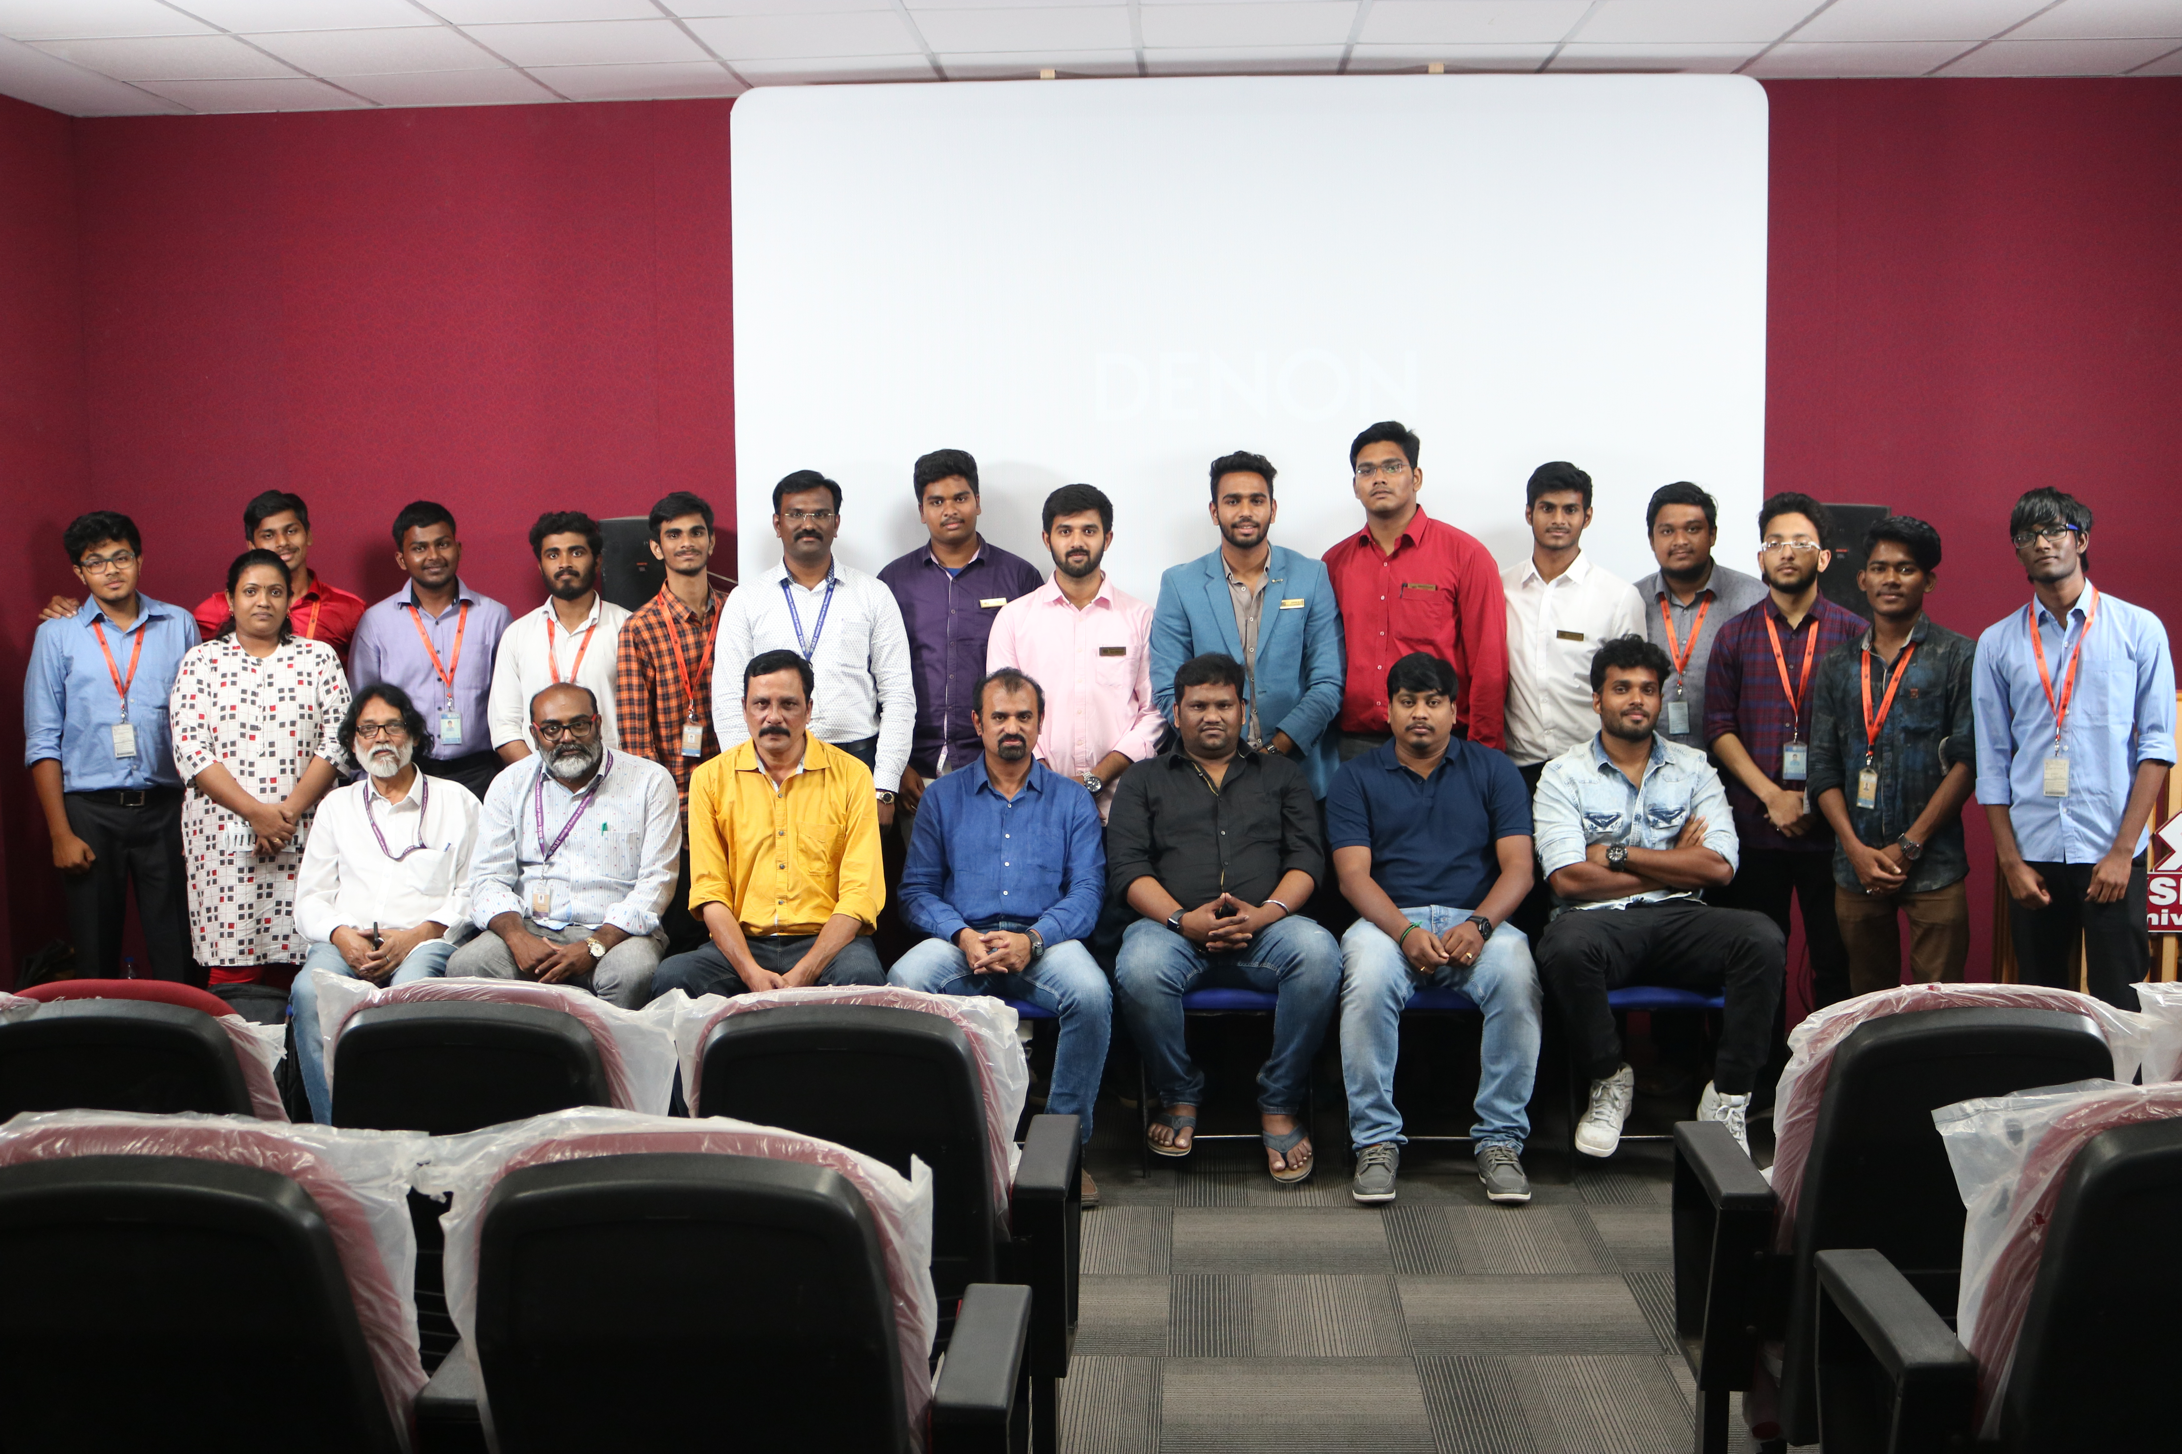
Team of Monocle’19

Event Name : Monocle’20
Date : March 5 & 6, 2020
Chief guest’s : Mr. Rahul Raj Put chutney Content writer, Editor, Youtuber, Designer etc.
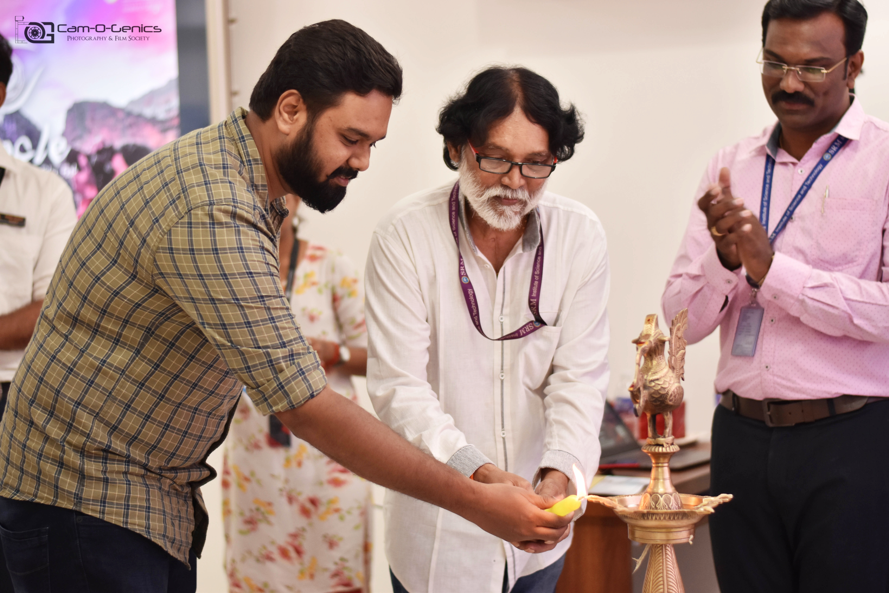
From the left Chief guest: Rahul Raj, Krishnaswamy Cameraman Film Tech, Coordinator C.Aravindan
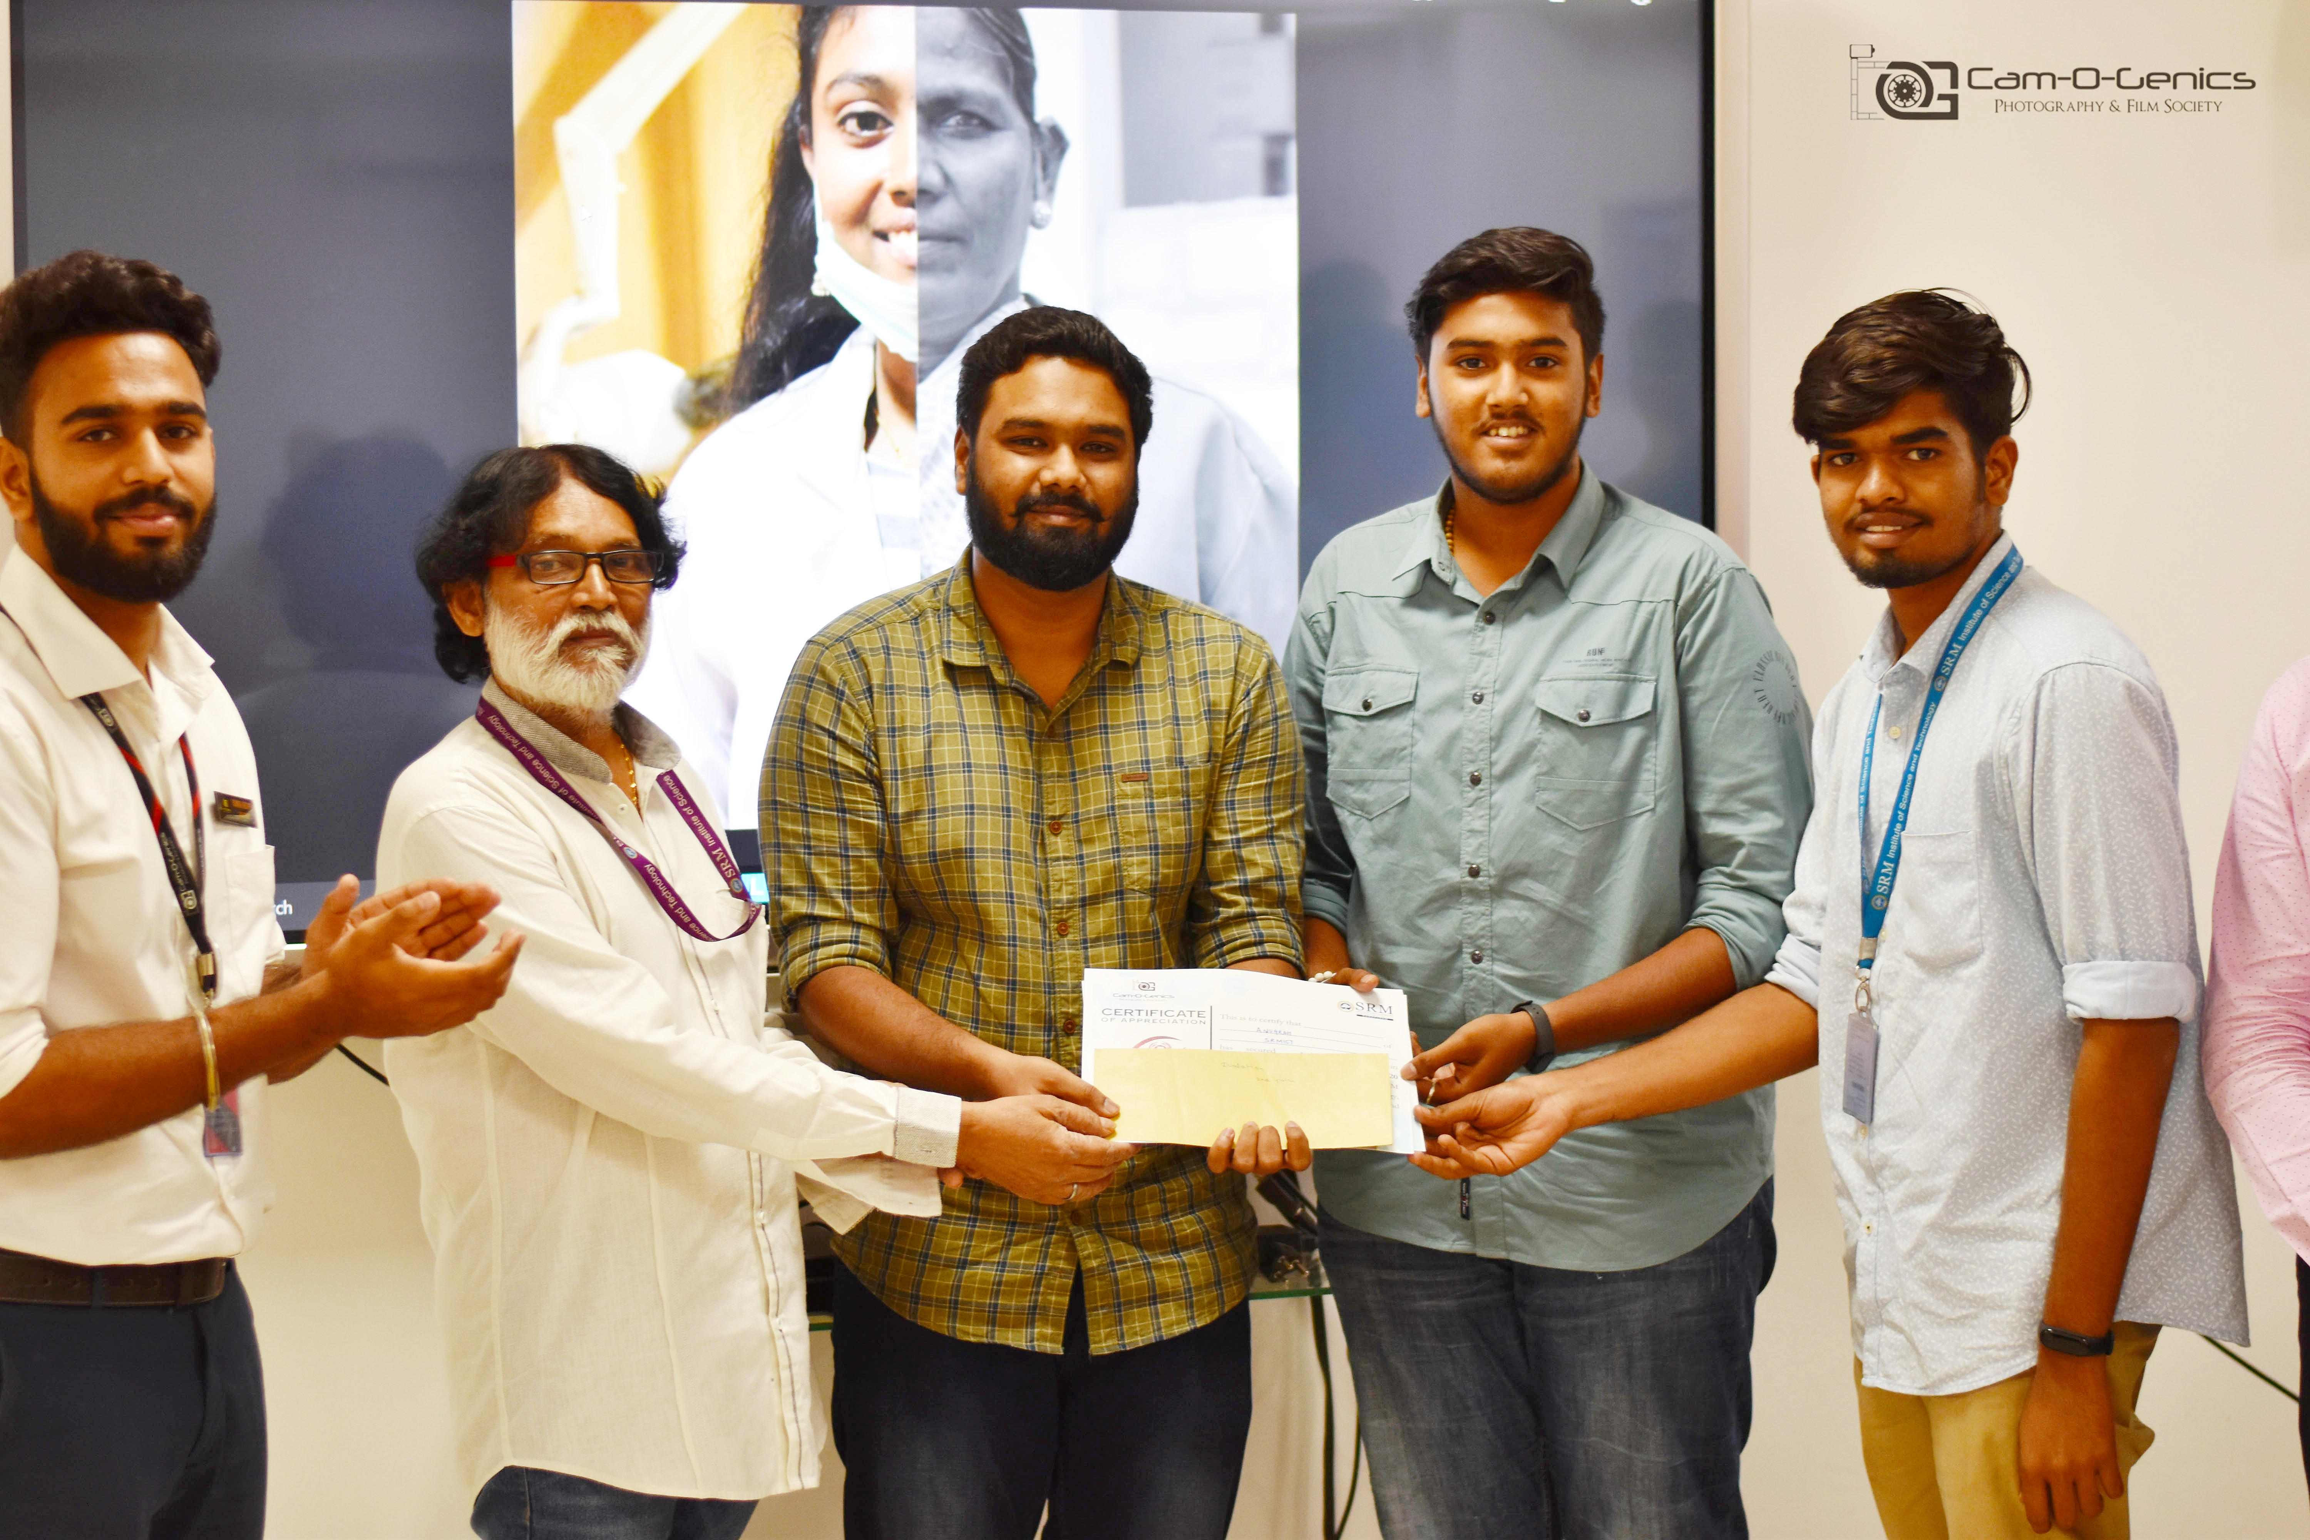
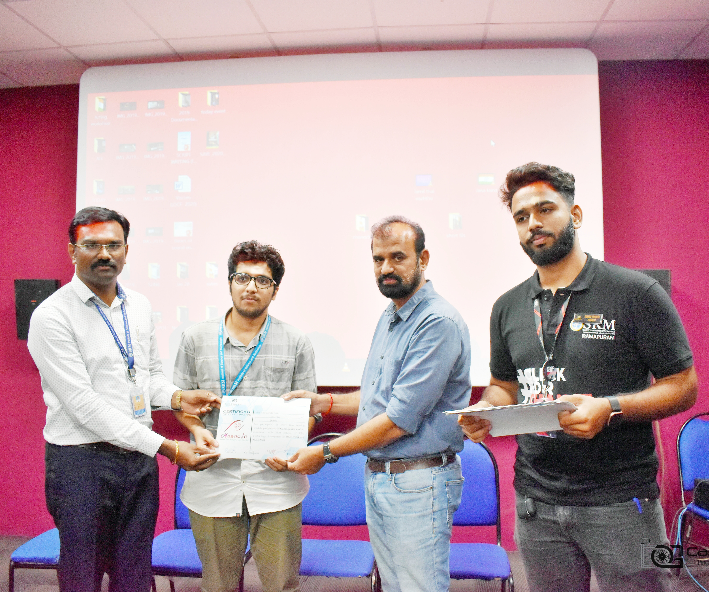
From the left Coordinator, Participants, R D Balaji HOD-Film Tech, Student President
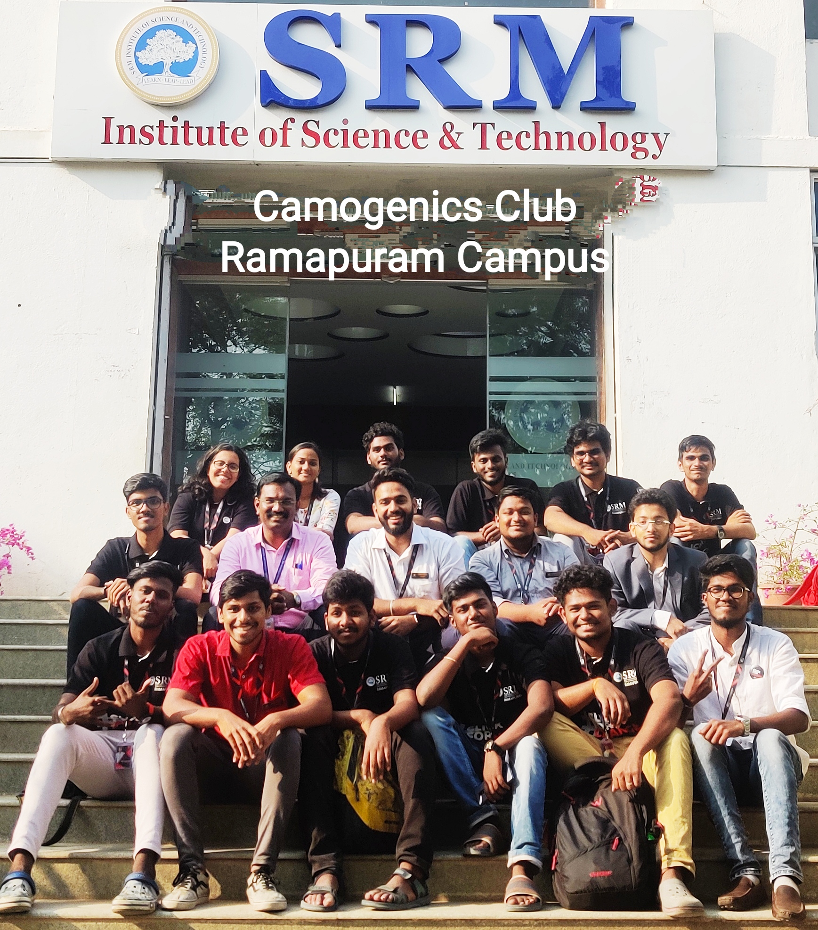
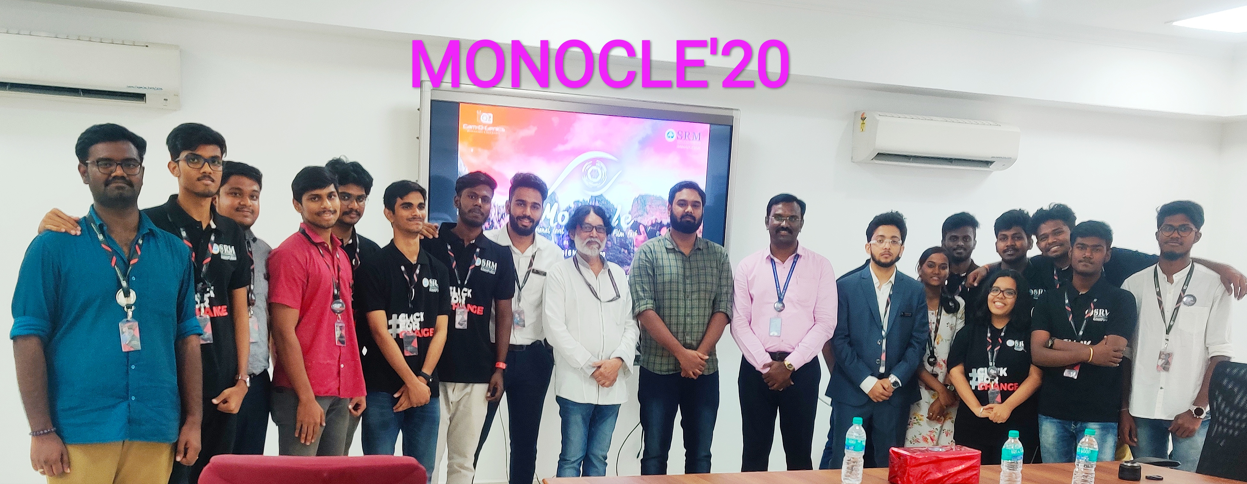
Team of Monocle’20

Event Name : Souvenir release
Date : March 7, 2015
Chief guest’s : Actor John Vijay
The chief guest “Mr. John Vijay” Cine Actor released the 1st Souvenir of the club during Cultural Fest named STRINGZ’15 on 07.03.15
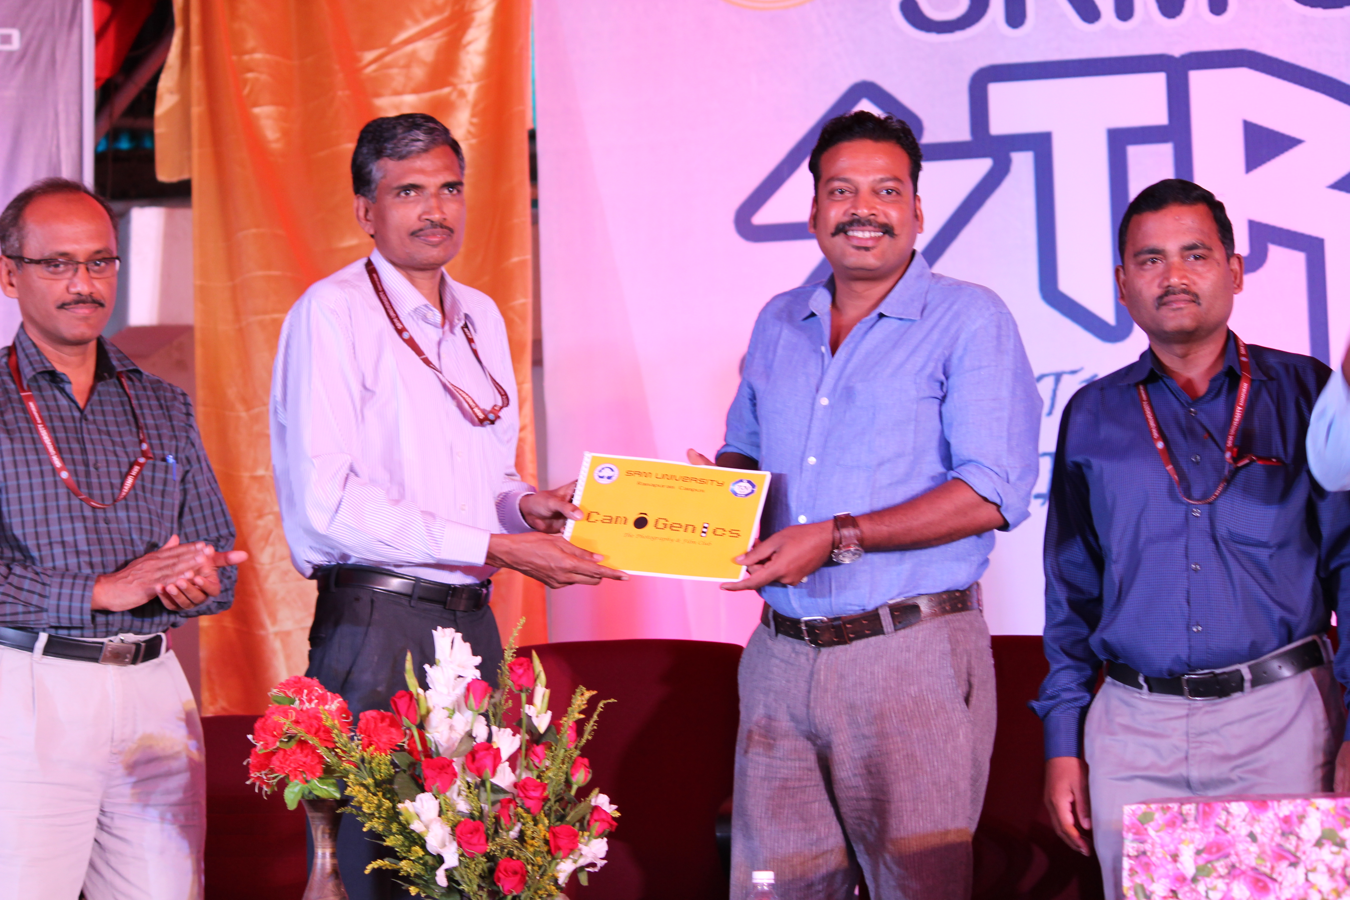
From Left VP(Academic): Dr. L. Antony Micheal Raj, Dean: Dr. V. Subbiah Bharathi, Chief guest: John Vijay, VP(Admin): Dr.J.Jagadeesan

